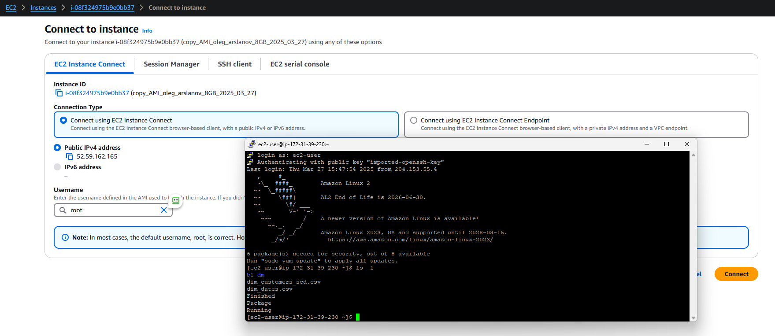**Task 2 Create cheapest EC2 virtual machine**

I search EC2 and open it. Name it: EC2_PostgreSQL_Server_oleg_arslanov. Choose Amazon Linux. Choose instance virtual server: t2.micro

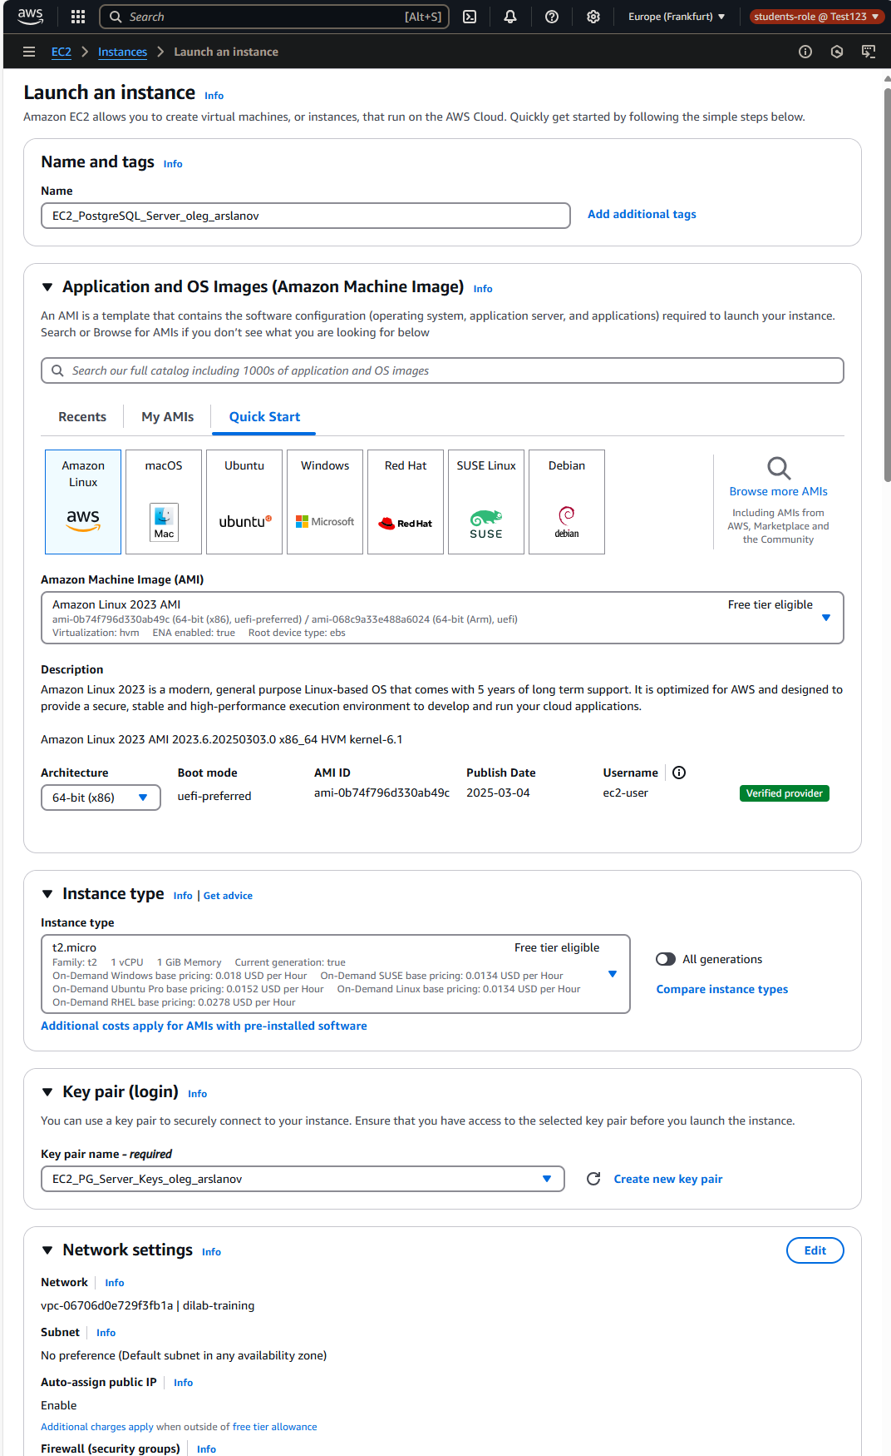

I created public key … for secure connect to my instance

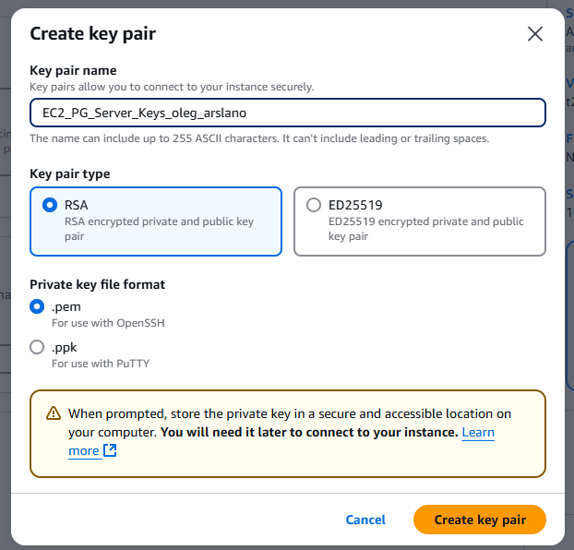

Select existing security group (it is ‘virtual firewall’. It is controle input and output traffic and for connect to another AWS services)

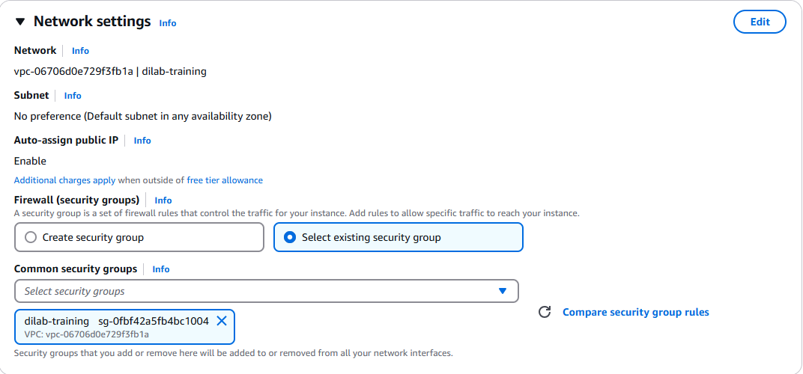

Create Role ‘AWS_EC2_full_access_S3’ allow S3 access to my EC2 machine (it is created already by admin role with policies … we only connect to that role)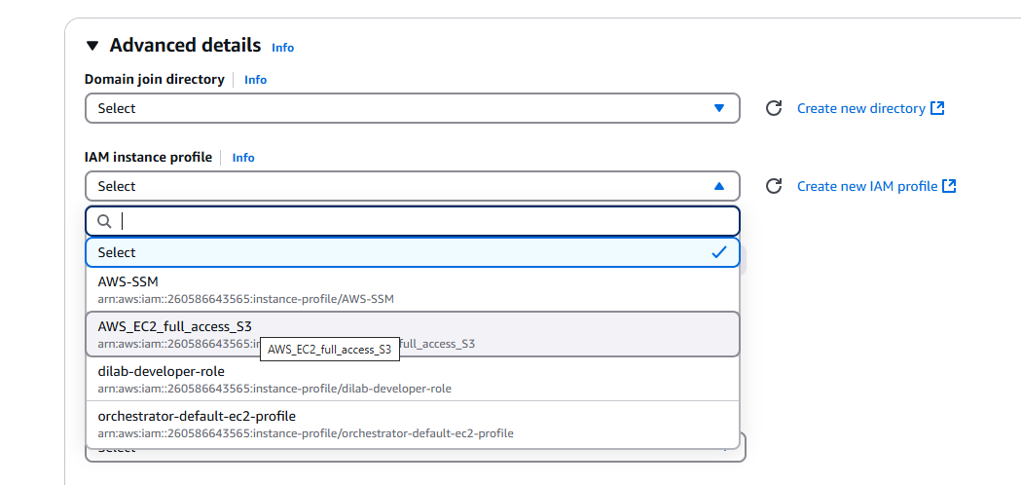

Success created instance

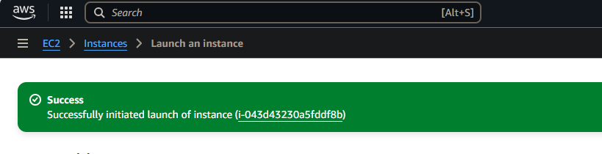

I check that security group allow open all type and all ports … only need here to change my IP address (when I launch with VPN my IP is changed … I need adding that IP address)

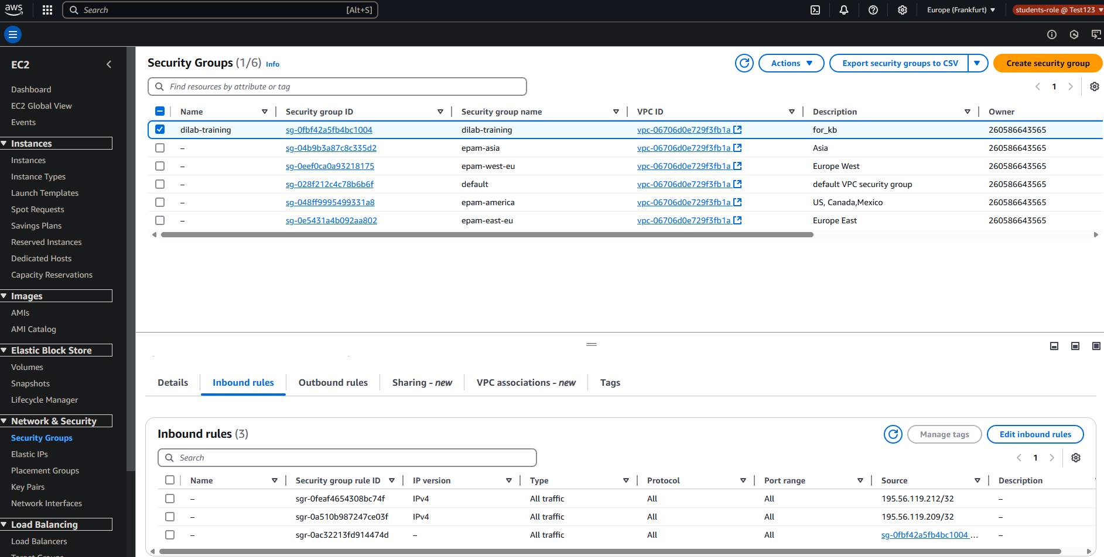

Then I connect to my EC2_PostgreSQl_Server_oleg_arslanov2. 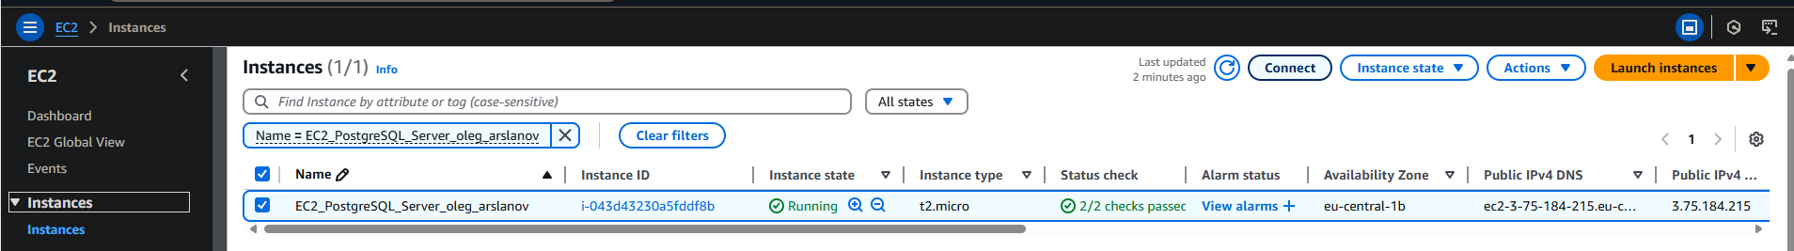

Then I need to connect to instance. I try to EC2 Instance Connect but got this message I think I can’t do that because policies of my role deny do that

So I connect with SSH … I need to download Putty program to connect to the servers (instance in AWS).

Use Putty key generator to generate private SSH key

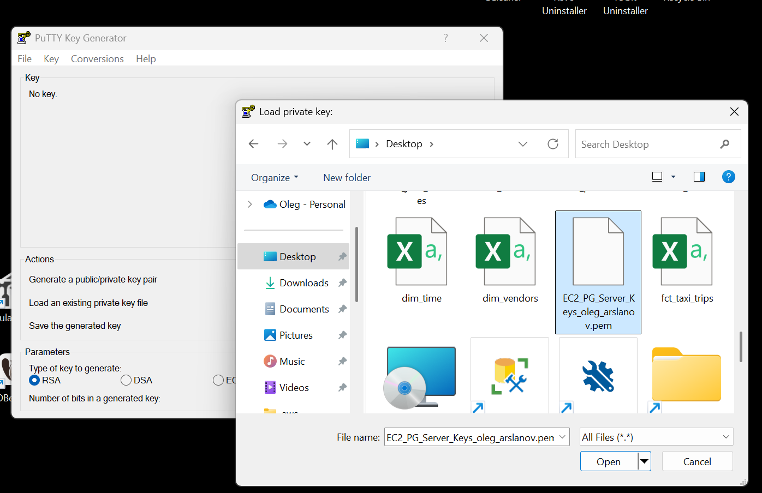

Import our created key from AWS . So we get private SSH key from putty

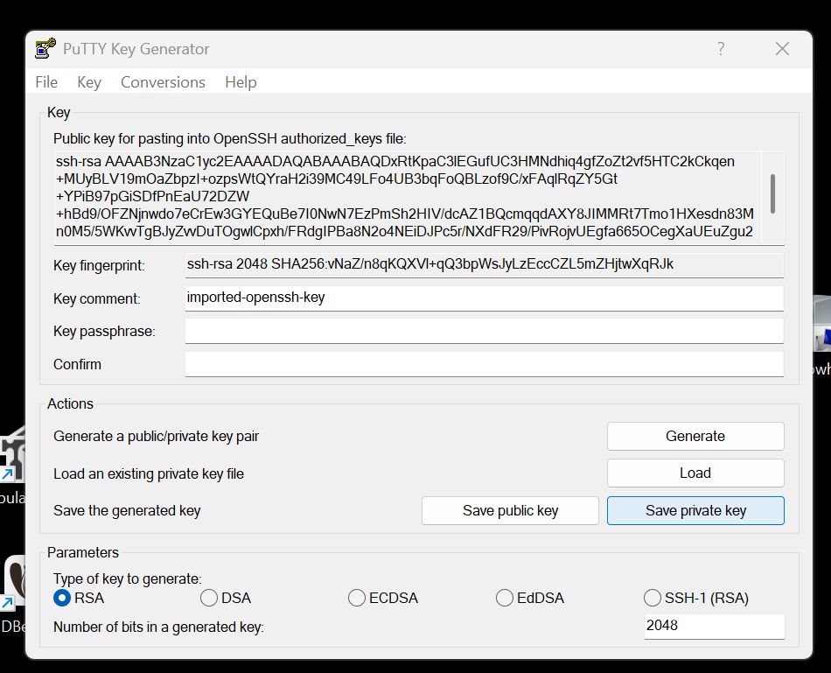



So next we configure PUTTY program adding private SSH key and Public DNS copied

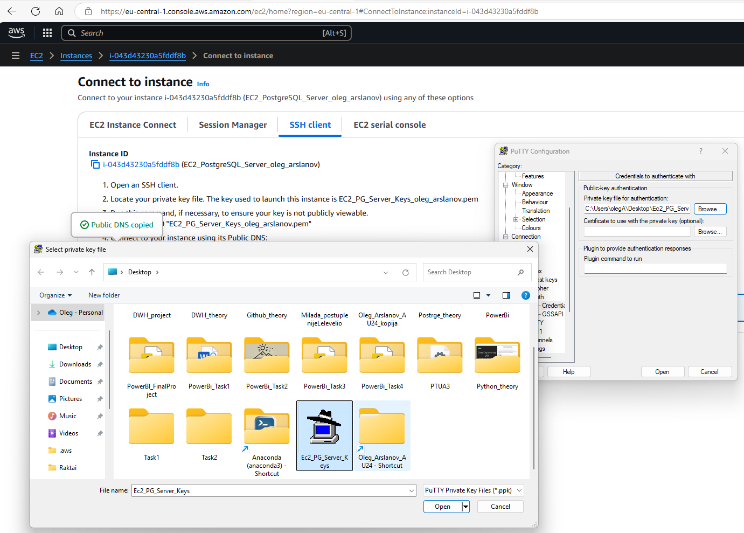

So I connect with PUTTY to my server (EC2)

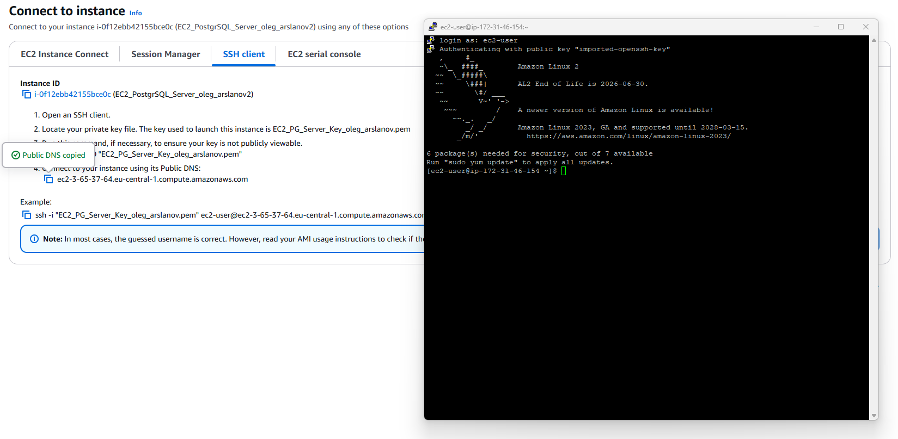

Now I need to install in this server PostgreSQL

I create repository for PostgreSQL

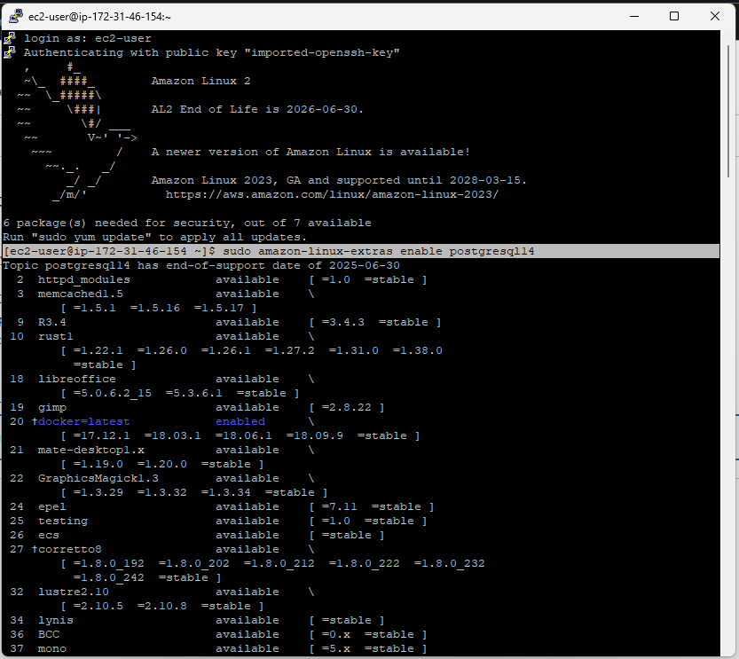

Install PostgreSQL

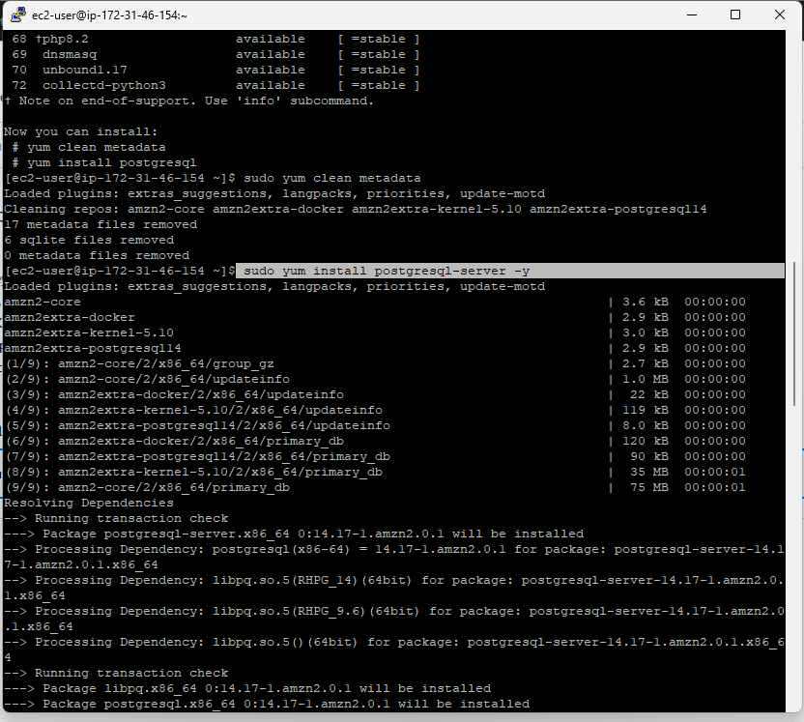

Inicial DB, enable PostgrSQL and check status

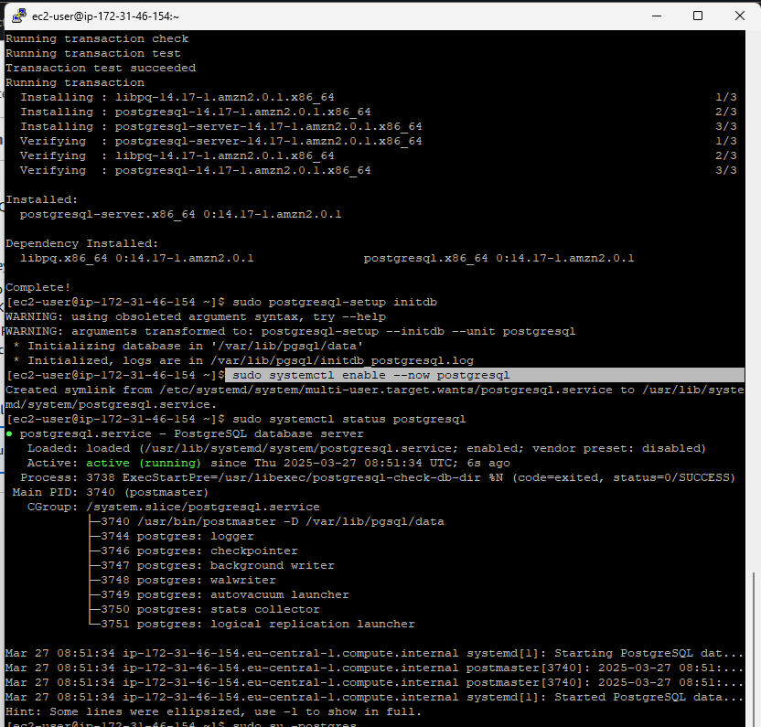

Creating DB and user

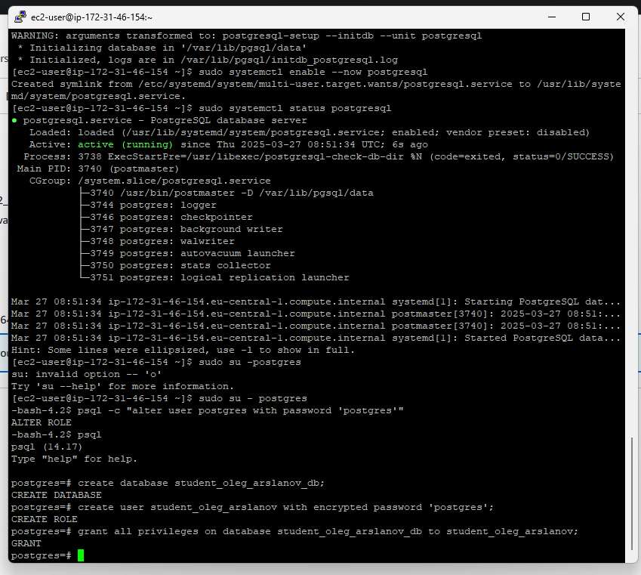

Check active network ports

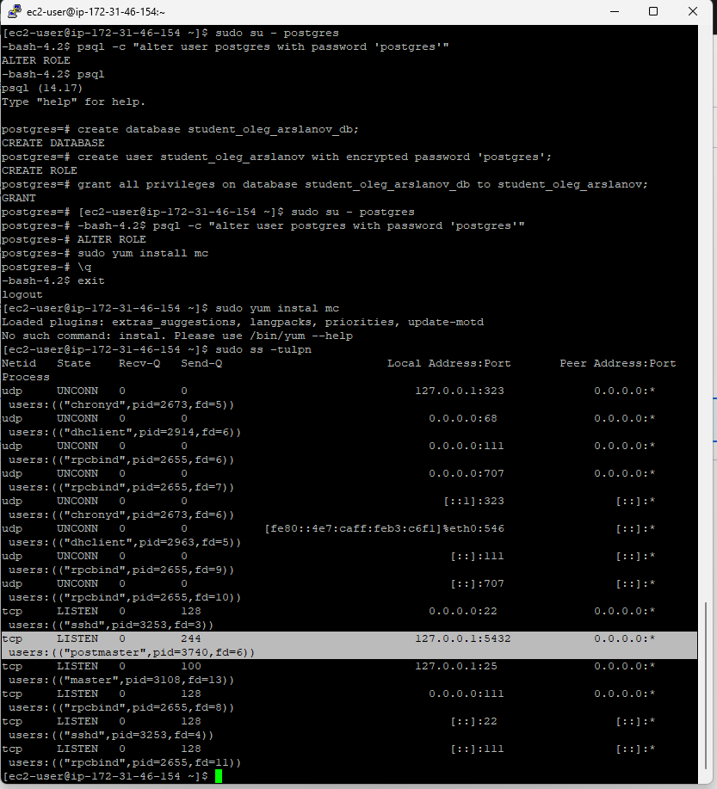

So here I see that 127.0.0.1:5432 it is my only my address with my port … so I can listen only my computer. I need to modify files:

1. config with command : sudo nano /var/lib/pgsql/data/postgresql.conf. Change #listen_addresses = 'localhost' to listen_addresses = '*'
2. sudo nano /var/lib/pgsql/data/pg_hba.conf

Add to the file end:

host all all 0.0.0.0/0 md5

When I did that I check

So here we check that port is listen all IPv4 interface on port 5432 ( 0.0.0.0:5432). So we have connection and we can connect to PostgreSQL with DBeaver



Connecting to DBeaver. In Host I use public DNS copied from Connect to instance -> SSH client -> connect to your instance using its PublicDNS -> copied

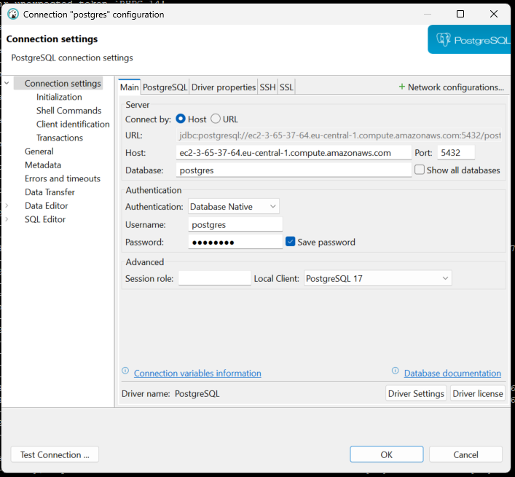

**2. We want to add Postgre files from S3 to EC2 postgreSQL**

Firstly I check what we have in our S3 . We have PowerBi file and DWH bl_dm all 9 tables

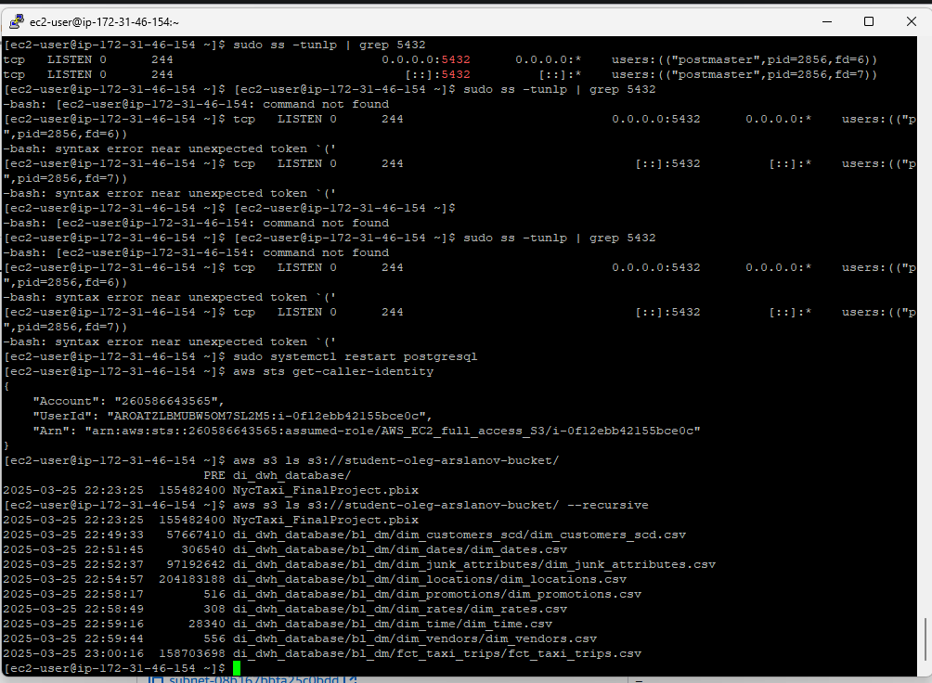

From that command I got addresses of my files in S3. And I can download from S3 to EC2.

So I use command for download folder bl_dm: aws s3 cp s3://student-oleg-arslanov-bucket/di_dwh_database/ . –recursive

And use command for separate files like: aws s3 cp s3://student-oleg-arslanov-bucket/di_dwh_database/bl_dm/dim_dates.csv/ . --recursive

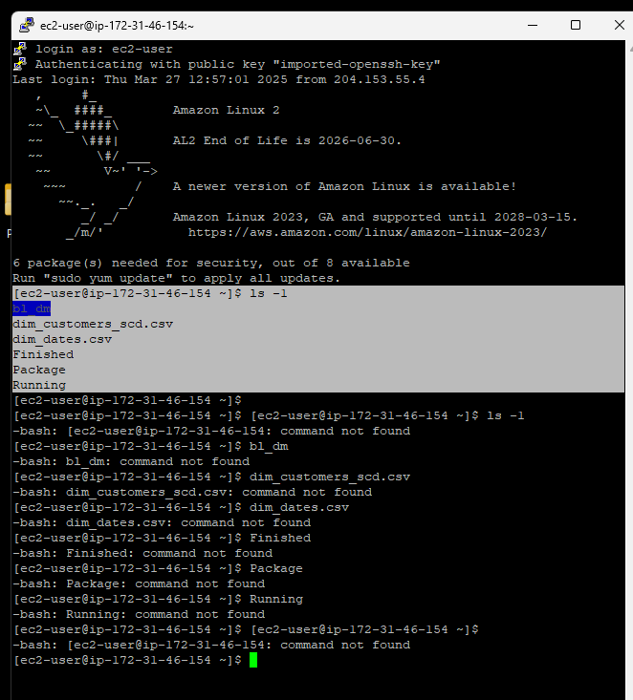

**Create snapshot and AMI for 8 gb EBS**

First I open my EC2 instance anf=d get info about my virtual disks

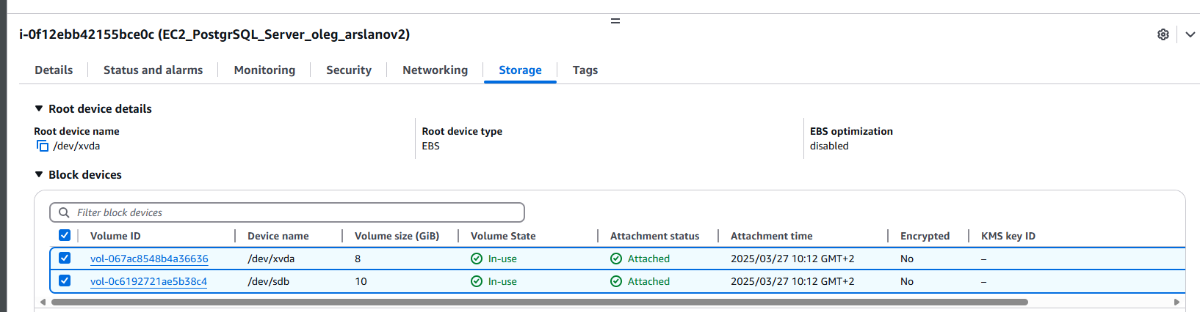

Then I fount EBS in Volumes and add tags

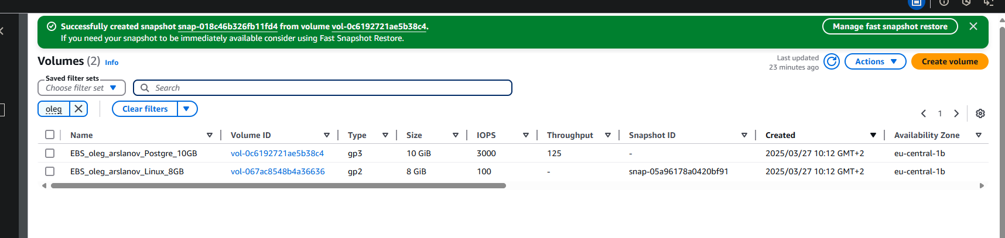

Then I go to Instances meniu and choose 8GB EBS and push on button Actions and select AMI. Then I got image … from this image I can create new 8GB EBS identical

So I got new copied virtual drive is identical



**Create web page and install apache web server**

Created simple web site index.html

Upload simple web page to the bucket

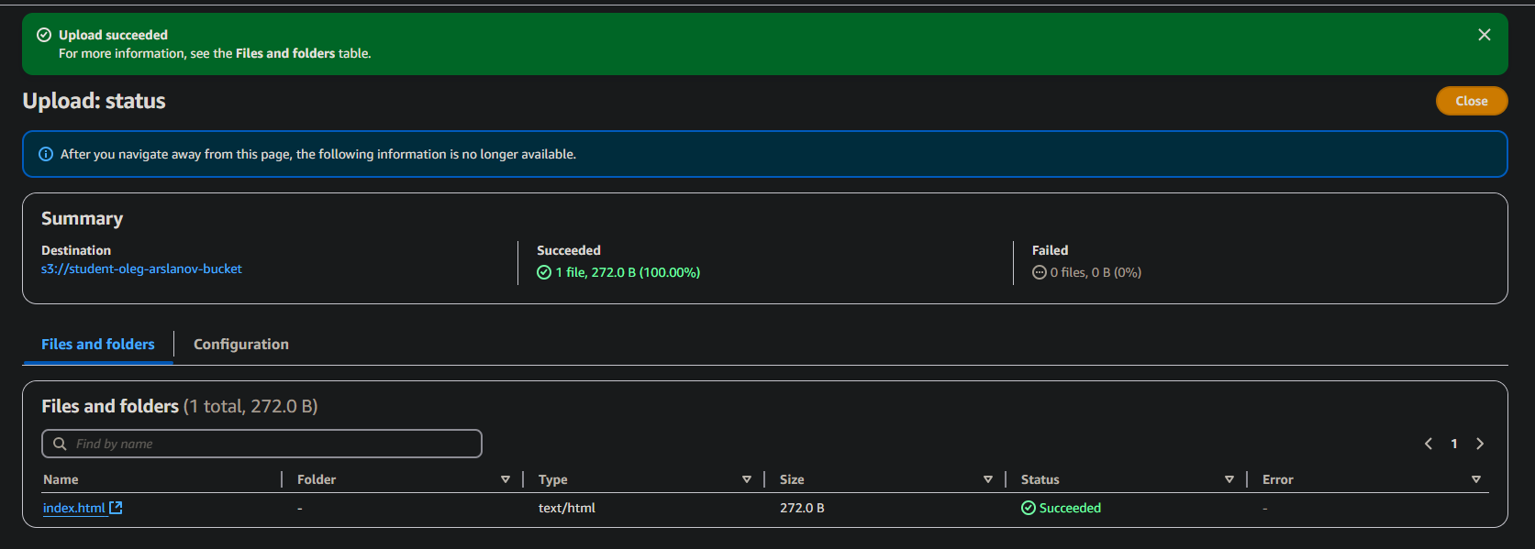

Then copied item.html from S3 to EC2 with CLI command into PUTTY:

**sudo aws s3 cp s3://student-oleg-arslanov-bucket/ index.html /var/www/html/**

Start Apache HTTP service in PUTTY :

**sudo systemctl start httpd**

Then I move HTML site to Apache web site folder(so we made our EC2 in web site that we can access from internet):

**sudo mv /tmp/index.html /var/www/html/**

I found address for we can check we can see our web site

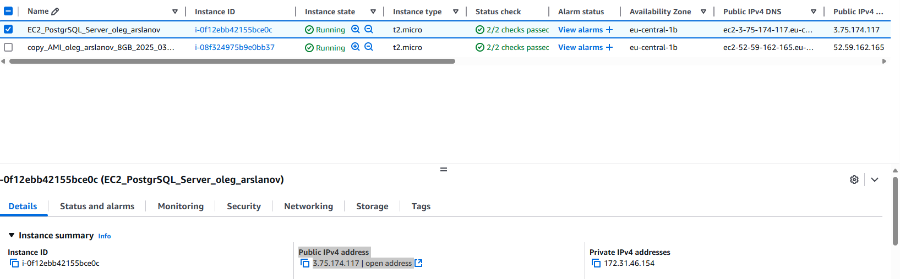

Check yes we have index.html in our EC2

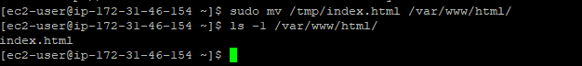

Then add address to browser and can see our web site

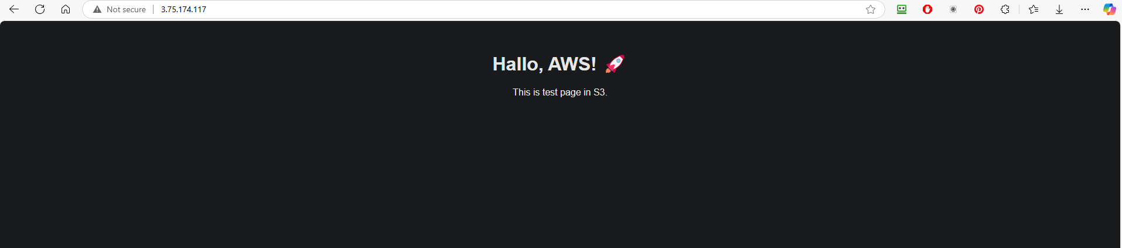

This step demonstrates how a simple static website can be hosted in the cloud using AWS EC2 and Apache.  
By deploying a web server on a virtual machine and exposing it via public IP, we published content to the internet without using any physical infrastructure. Super now I can add my website to internet with cloud technologies by myself 😊

**Create SNS notification**

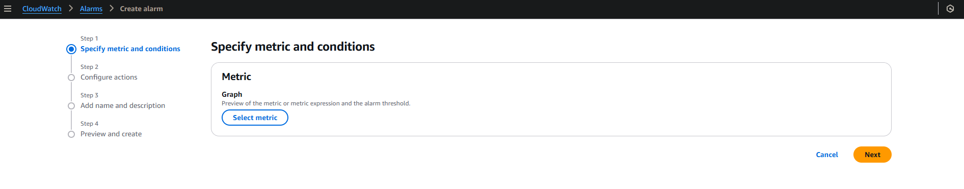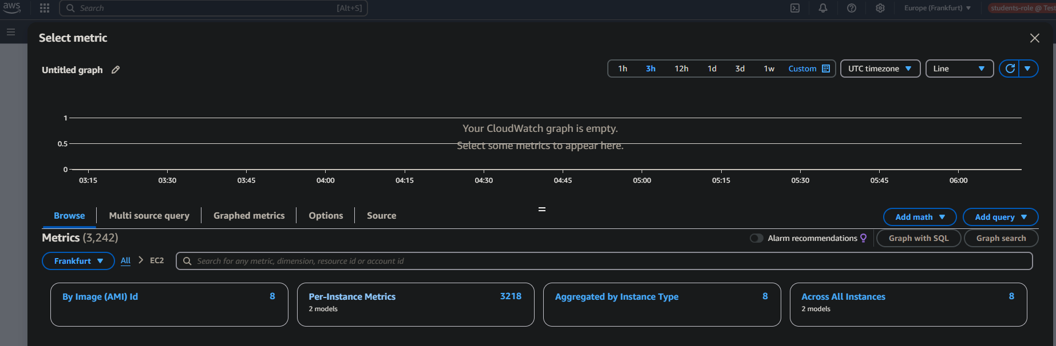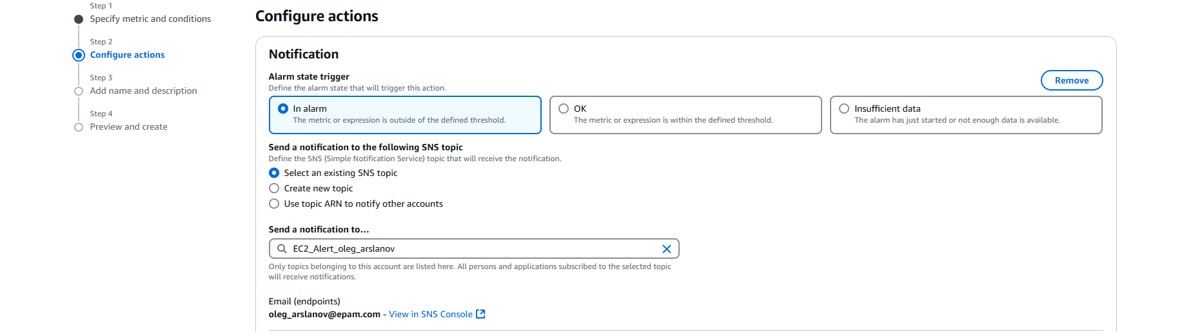

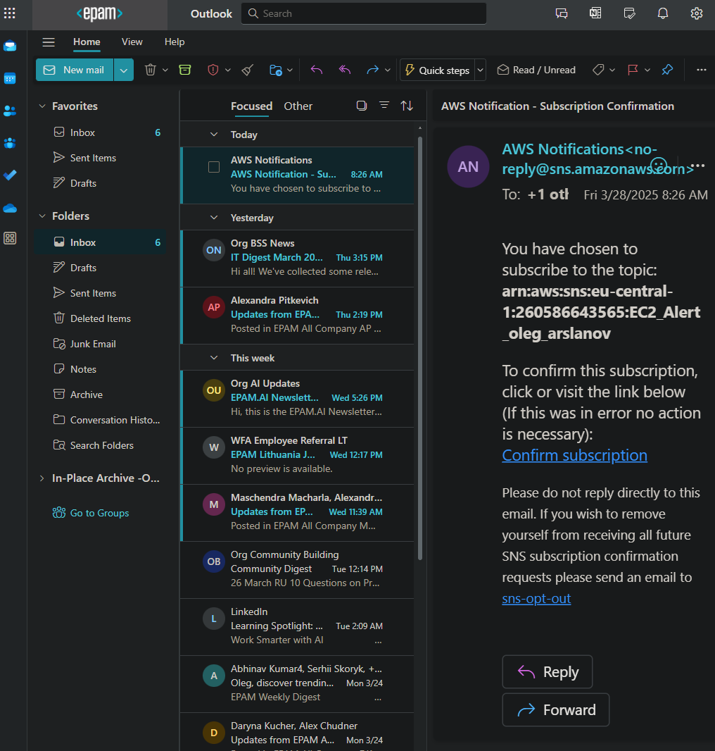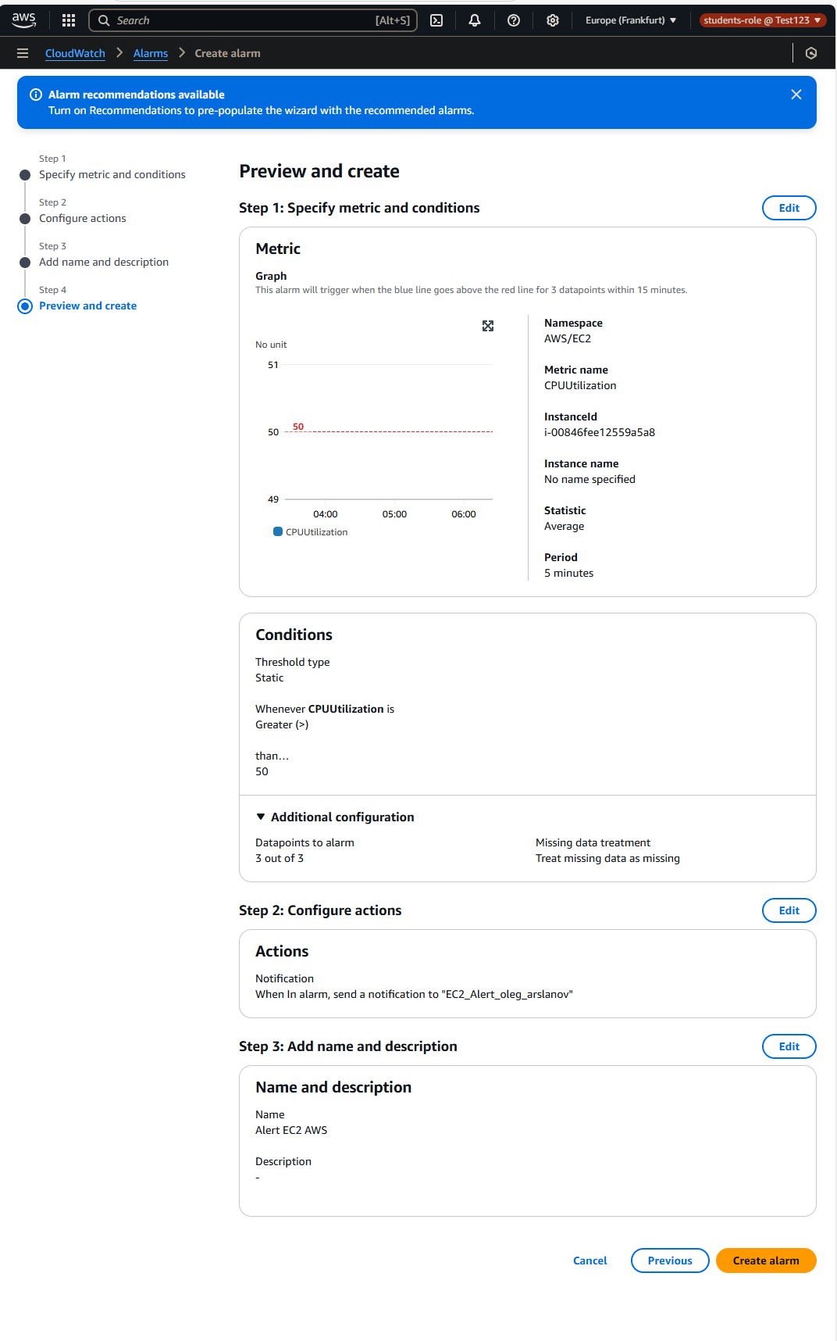

So when we have > 50% load of our EC2 Processor longer than 5 minutes we get message in email

**Create same EC2 Virtual machine with CloudFormation script**

So I create code and save to file ec2_clouformation.yaml:

AWSTemplateFormatVersion: '2025-03-28'

Description: EC2 instance created by CloudFormation with existing Security Group

Parameters:

  KeyName:

    Description: EC2 KeyPair for SSH access

    Type: AWS::EC2::KeyPair::KeyName

  InstanceType:

    Description: EC2 instance type

    Type: String

    Default: t2.micro

    AllowedValues:

      - t2.micro

      - t2.small

      - t3.micro

Resources:

  MyEC2Instance:

    Type: AWS::EC2::Instance

    Properties:

      InstanceType: !Ref InstanceType

      KeyName: !Ref KeyName

      ImageId: ami-0faab6bdbac9486fb  # Amazon Linux 2 (eu-central-1)

      SecurityGroupIds:

        - sg-0eef0ca0a93218175       # existing sg epam-west_eu

      Tags:

        - Key: Name

          Value: student_oleg_arslanov_from_cf

        - Key: owner

          Value: student

      BlockDeviceMappings:

        - DeviceName: /dev/xvda

          Ebs:

            VolumeSize: 8

            VolumeType: gp2

Upload to S3

Use command to copy from S3 to EC2

**sudo aws s3 cp s3://student-oleg-arslanov-bucket/ec2_cloudformation.yaml /tmp/**

Then I use it code to create new EC quickly (only on my local computer with CMD):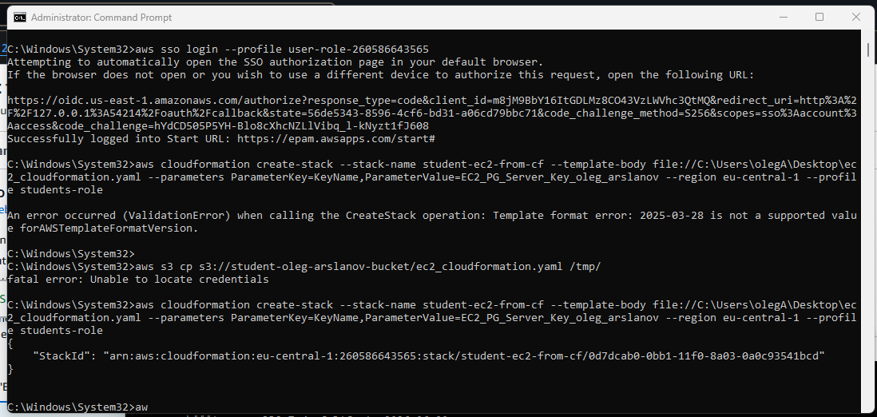

Yes we got that new quickly Virtual machine

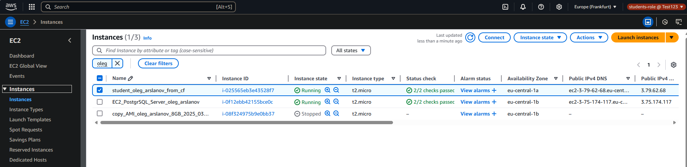

For additional punkts sorry but I don’t have time 😊 I am late 😊 need to move to another task, because because …